STEPS/STAGES

The key components of Digital Image Processing (DIP) encompass various stages and techniques employed in the processing and analysis of digital images. These components include:
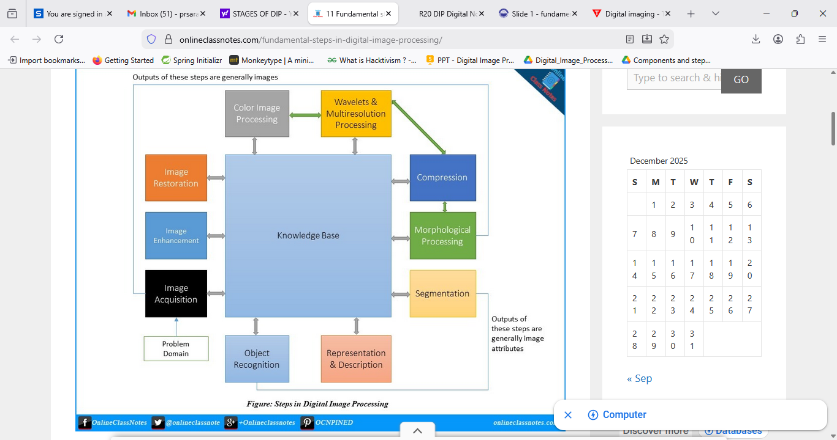

Image Acquisition: This initial stage involves capturing digital images using devices such as cameras, scanners, or sensors. The quality and characteristics of the acquired images significantly impact the effectiveness of subsequent processing steps.
Image Enhancement: Image enhancement techniques are used to improve the visual quality of images by emphasizing certain features or enhancing specific aspects such as contrast, brightness, or sharpness. Histogram equalization, contrast stretching, and spatial filtering are examples of enhancement techniques.
Image Restoration: Image restoration techniques are employed to recover degraded images caused by factors such as blur, noise, or compression artifacts. Restoration algorithms attempt to estimate the original image by modeling and reversing the degradation process.

Color Space Conversion: Color image processing in Digital Image Processing (DIP) involves manipulating and analyzing images that contain color information. Color images are often represented in different color spaces, such as RGB (Red, Green, Blue), HSV (Hue, Saturation, Value), or CMYK (Cyan, Magenta, Yellow, Black). Converting between color spaces may be necessary for specific processing tasks.
Image Compression: Image compression techniques reduce the storage space and transmission bandwidth required for digital images while minimizing the loss of visual quality. Compression algorithms can be either lossy (e.g., JPEG) or lossless (e.g., PNG), depending on the degree of compression and the preservation of image fidelity.
Image Segmentation: Image segmentation divides an image into meaningful regions or objects based on their characteristics, such as color, texture, or intensity. Segmentation is essential for tasks such as object detection, image understanding, and feature extraction.

Feature Extraction: Feature extraction involves identifying and extracting relevant information or features from images, such as edges, corners, textures, or keypoints. These features serve as input for subsequent analysis or recognition tasks, such as object detection or image classification.
Object Recognition and Classification: Object recognition and classification involve identifying and categorizing objects or patterns within images. This process often utilizes machine learning algorithms trained on labeled datasets to recognize objects based on their visual characteristics.

These key components of Digital Image Processing collectively enable a wide range of applications across various domains, including medicine, remote sensing, surveillance, robotics, and entertainment. Advances in algorithms, hardware, and software continue to drive innovation and expand the capabilities of digital image processing techniques.

